The MUSEUM Box Project

SYMBOL: A concrete object that stands for an abstract idea.

RATIONALE: Throughout Catcher in the Rye, many symbols come to light:
- THE HUNTING HAT: escapism, isolationism, and individuality
- THE CENTRAL PARK LAGOON: curiosity and innocence
- MUSEUM OF NATURAL HISTORY: Holden’s fantasy world where there’s secirtu in the fact that nothing ever changes
- ALLIE’S GLOVE: the memory of Allie

YOUR TASK: You will create your own shadowbox or museum exhibit containing four symbols from your life. For each of the four items you choose, you must write an explanation 3-5 sentences and tie it to one of Holden’s symbols or moment’s described in the book. You may include actual physical objects or pictures of the things you hold dear to you heart. You will be evaluated not on your choice of objects but on the connection you can draw between the world of the literature and your personal world. Please see a sample explanation paragraph and the rubric from which you will be evaluated.

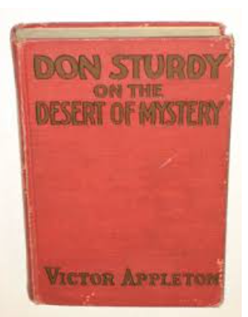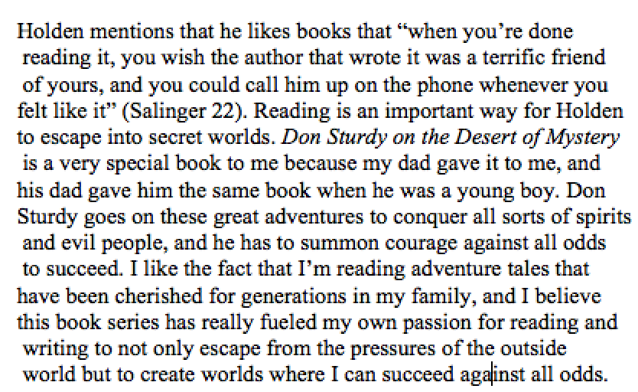

 | 2 points | 5 points | 5 points | 3 points
SYMBOL 1 | Object or picture included | Thorough explanation of object and its significance | Tied to quote from book; accurately explained and cited | Neat and professional
SYMBOL 2 | Object or picture included | Thorough explanation of object and its significance | Tied to quote from book; accurately explained and cited | Neat and professional
SYMBOL 3 | Objective or picture included | Thorough explanation of object and its significance | Tied to quote from book; accurately explained and cited | Neat and professional
SYMBOL 4 | Object or picture included | Thorough explanation of object and its significance | Tied to quote from book; accurately explained and cited | Neat and professional

TOTAL POINTS VALUE: 60 POINTS

DIRECTIONS: Put your objects and explanations inside a shoe box with a lid or secure inside a box to look like a shadownbox. Extra points will be awarded if you decorate the outside of your box.

