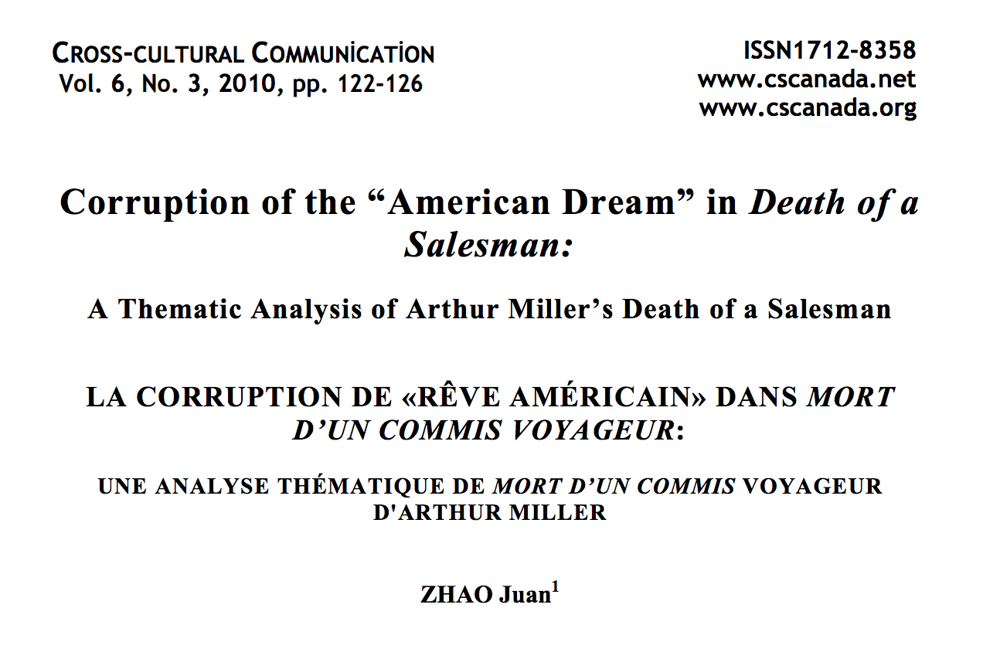

The “American Dream” is based on the “Declaration of Independence”: “We believe that all men are born with these inalienable rights—life, liberty and pursuit of happiness.” (Thomas Jefferson, 1776). This “dream” consists of a genuine and determined belief that in America, all things are possible to all men, regardless of birth or wealth; if you work hard enough you will achieve anything. However, Miller believes that people have been “ultimately misguided” and Miller’s play, Death of a Salesman, is a moving destruction of the whole myth.
The origins of the American Dream seem to have been rooted in the pioneering mentality of the 18th and 19th century immigrants, most of them came to America because of a new and better life, in particular, the opportunity to own one’s land. But land rented out and so cities developed and massive variations arose in wealth, which meant that this “American Dream” changed from being a potential reality, into being a dream, like the name implies. Most of Miller’s plays are directly or indirectly about the American Dram, because ultimately this dream wasn’t going to succeed as lots of people wished. Death of a Salesman written in 1949, is a moving destruction of the whole myth.

To be hard working, honest and have ambition were the ways of the American Dream. This leads to success, wealth and in due time-power. But this dream for everyone develops, and encourages greed, selfish behavior, pride and rivalry between one another. Willy Loman is “caught-up” in this American Dream. It causes business to develop in the world.
Capitalism and also the profit motive and competitive instinct, makes Willy have a weakness in his personality. This weakness is caused by a combination of business pressures. Willy wants to prove himself through a successful salesman, but as he fails, his own life destroys him.
“I’m the New England man. I’m vital in New England.” “Never leave a job until your sixty.”
Willy’s quotes above show that he is insecure, and is not a successful businessman he says he is.
Miller based Willy’s character on his own uncle, Manny Newman. Miller said, “That homely, ridiculous little man had after all never ceased to struggle for a certain victory,
the only kind open to his this society --- selling to achieve his lost as a man with his name and his son’s name on a business of his own.” This explains exactly what he has in mind for Willy to be – as he was, “trying to achieve his lost self.” The things that are meant to happen in business are success, wealth and esteem. This is what Ben has achieved and done. Miller stresses his success and material reward in Ben. He does this by Ben repeating himself a lot, “I walked into the jungle, and when I came out I was rich.” But Ben also has emptiness in spite of his success. In the eyes of the audience, he has no real happiness.

QUESTION:
The title character Willy Loman pursues his own version of the American Dream, fails, and decides to commit suicide because he is unable “change with the times”. What, specifically, attributes to his failure?

Carefully craft a 4-7 sentence essay in which you address this question and prove your claim with evidence from the play in the form of indirect quotes and a direct quote from the Mgamis article.

When you are finished, create a Works Cited entry for both the play and the Mgamis article.

ESSAY RUBRIC/CHECKLIST

5 | 5 | 5 | 5
Grammar/punctuation (1 pt taken away per error). Includes spelling. | Content/Structure  Author restates question and accurately addressed question with specific details and sentence variety. | Play Example  Author correctly uses an indirect quote example from the play and explains it thoroughly. Author ALSO correctly formats a Works Cited entry. (1 pt taken away per error) | Article Example  Author correctly uses an direct quote example from the article and explains it thoroughly. Author ALSO correctly formats a Works Cited entry. (1 pt taken away per error)

