ROMANTICISM REVIEW

Open up your textbook to review “The Fall of the House of Usher” on pages 293-310 and complete the questions below.

Poe’s short story is littered with poetic lines that foreshadow Madeline’s death such as Roderick mentioning that “the lady, at least while living, would be seen no more” (300) and that he needed help for her “temporary entombment” (304). What other quotes can you find from the story that foreshadow Madeline’s demise and the overall theme of death in the story? What quotes can you find that are examples of other themes in the story?

Madeline’s death | “ “( )
Overall Death | “ “ ( )
Duality of Man | “ “ ( )
Supernatural | “ “ ( )

Please answer the following questions inn complete sentences.

- Describe the physical decay of the house juxtaposed against the moral decay of the family.

- What’s the significance of the story/poem in the story? How does the poem set up the end of the story?

- Do you believe Roderick buried his sister on purpose? Why or why not?

- What happened to the home after Roderick died? What did the narrator witness?

- Given the description of the interior of the house, what clues does the writer give that the narrator is entering a world much different than the world outside?

Watch the following video at http://www.bl.uk/romantics-and-victorians/videos/the-gothic (there’s also a link on the website). Please summarize what the video said about each of the following categories.

Place and Time | Power | Sexual Power
The Uncanny | The Sublime | Crisis
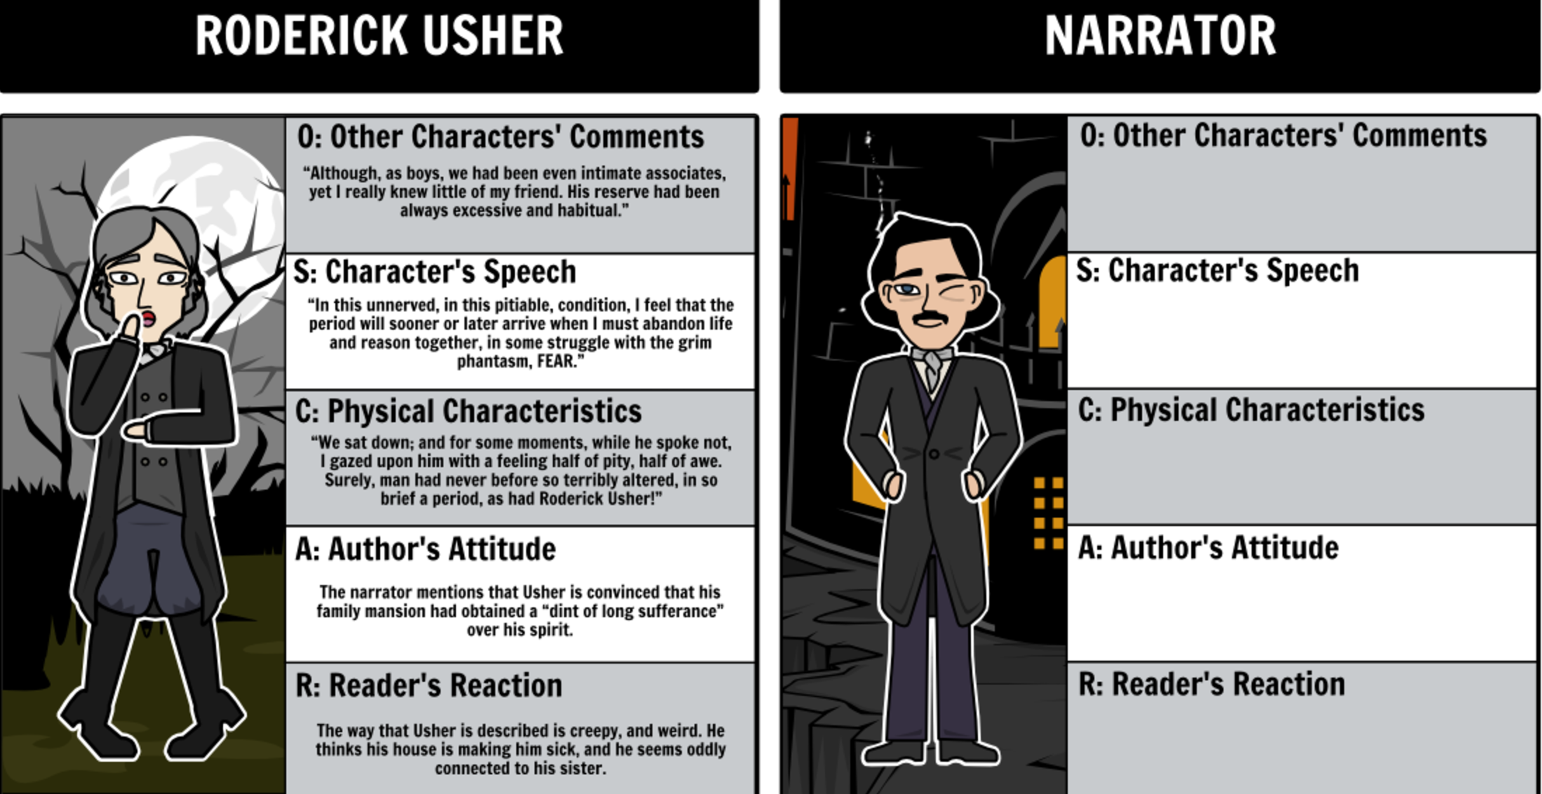

Complete the chart for the narrator above. In the space below, draw a detailed picture of the House of Usher as described in the opening of the story. Use as many specific details as possible!

