DRAMA 101 FLASHLIGHT LAB

What are the five purposes of light? What are the five properties of light?
1.) 1.)
2.) 2.)
3.) 3.)
4.) 4.)
5.) 5.)

In the following pictures, the light is coming from different angles to create a certain mood. Please mimic he picture. When you figure out which direction the light is coming from, put an “X” on the side of the picture to indicate where the light source is. Then, below the picture, write a few adjectives to describe the mood created by the picture. Lastly, email me a picture of you imitating one of the photos: engelberta@cvuhsd.org

1.) 2.) 3.)
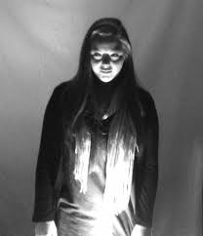
Tone: Tone: Tone:

4.) 5.) 6.)
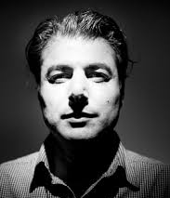
Tone: Tone: Tone:

