CSU EXPO-Engelbert
2018

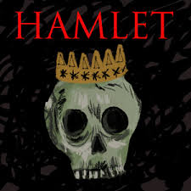

Is one life more valuable, or worth more, than another life?

Before I Read | After I Read
Reflection:

HAMLET BG PPT

- Born ____________ in _________________________ and Died in __________

- Married ____________________________ SHE WAS WAY OLDER!

- Kids:

- THEATER CAREER
- Member/Part Owner
- L.C.M built ______________in 1599; he was primary investor
- In 1613,

- He wrote __________ plays and ________ sonnets

- Describe the language he wrote in/his vocabulary:

THEATRICAL CONVENTIONS (please list)
1.)
2.)
3.)
4.)
5.)

Difference between a soliloquy and an aside:

Name 3 of Elizabeth’s Problems:

1.)

2.)

3.)

What’s the folio? A quarto?

Where was Hamlet thought to be drawn from?

Charting the Plot: William Shakespeare’s Hamlet

Section of the Play | Events | Significance
I.i | -2 Sentries outside the gate relay the given circumstances of the play:  -Hamlet Jr. of Denmark killed King Fortinbras of Norway, therefore  gaining back their lands stolen by Norway  -Fortinbras Jr. is raising an army to get back the lands and avenge the  death of his father  -Hamlet Sr. is dead  -The guards have seen the ghost of Hamlet Sr. at midnight  -Horatio comes to see if it true. He tries to speak to the ghost but fails. He decides to tell Hamlet what he as scene. | -The two opening characters deliver exposition to inform the reader as to the circumstances when the play begins  -The vision of a ghost sets a mysterious but tense tone as warlike factions are building against Denmark
I.ii | -Claudius (Hamlet’s Uncle) marries Queen Gertrude (Hamlet’s mother) because he thinks the kingdom needs a king to fight off impending war  -He writes a letter to the Uncle of Fortinbras telling him is nephew is a sore loser and raising an army against Denmark without his consent  -Laertes asks to go back to school after the combined funeral/wedding  -Hamlet delivers his first suicide soliloquy  -Horatio tells Hamlet he saw his father’s ghost, and Hamlet bids him keep it a secret because he suspects foul play | -The major emotional, character-driven conflict is established: Hamlet is suicidal and feels what a screenwriter would call as the “all is lost” moment  -When Hamlet learns that his father’s ghost is about, he vows to find out the reasoning (his objective or quest)
I.iii | -Laertes gives his sister some brotherly advice not to fall under the spell of Hamlet and sleep with him before marriage; he’s a man and will say anything to get her to have sex with him  -Also, don’t risk your reputation or chastity  -Polonius gives his son some advice (don’t speak out of turn, be careful who you trust, dress the part, don’t get into debt or loan people money, etc.)  -Polonius tells Ophelia to be careful of spending “private” time with Hamlet because the court is talking-He tells her to play hard-to-get | -reveals how men and society view women  -focus on emotional manipulation
I.iv

I.v
II.i
II.ii
III.i
III.ii
III.iii

III.iv
IV.i
IV.ii
IV.iii
IV.iv
IV.v
IV.vi

IV.vii
V.i
V.ii

CHARACTER LIST

Hamlet

Claudius

Gertrude

Ophelia

Laertes

Polonius

Horatio

Fortinbras Jr.

The Ghost

Rosencrantz and Guildenstern

Osric

Voltimand and Cornelius

Marcellus and Barnardo

Francisco

Reynoldo
Introduction to Hamlet Focus Questions
Task: Throughout the PowerPoint Presentation, you will be asked to respond to focus questions. Please write your response below.
Question: | Answer:
- What if the official title of Hamlet?

- What are the themes explored in Hamlet?

- Why is Hamlet so powerful and influential?

- How does Hamlet depart from contemporary dramatic convention?

- What type of character is Hamlet often perceived as?
- What line is a clear example of existentialism?
(Hint: It is the most famous line from the play)

ALL RIGHT! LET’S DIG IN!!!!! I.i.

1.)Who opens the play, and what happens?
(I.i.)

2.) What happens when the guards asks the ghost to speak? (I.i.)
3.) What background knowledge on the king does Horatio give us? (I.i.)

Hamlet’s First Soliloquy (29-31)
Oh that this too sullied flesh would melt…

Questions: | Answers:
1. What reason does Hamlet give for not killing himself?

2. Hamlet says that the kingdom is “an unweeded garden that grows to seed-things rank and gross in nature possess it merely”. What does he mean?

3. What example does Hamlet give as to why his father was good to his mother?

4. Critics often examine Shakespeare’s ill opinion of women as the weaker sex. Cite the line Hamlet says to confirm this, and explain what is means.

5. Why must Hamlet “hold thy tongue”?

6. Soliloquies are about struggling with a decision. What decision does Hamlet struggle with, and what does he ultimately decide?

HAMLET I.ii COMPREHENSION QUESTIONS

Below are comprehension questions for Act I Scene 2 of HAMLET. Please answer the following questions and cite evidence from the text to support your answers. See the example below that addresses the question and cites evidence in the correct form. TURN IN ON A SEPARATE PIECE OF PAPER!

SAMPLE QUESTION: Look at the first section of lines we hear from King Claudius, Hamlet’s uncle/step-father. What should rub you the wrong way about the King’s message to the court? Write a specific passage from the section of Lines 1-16 and explain what bothers you about the passage.

SAMPLE ANSWER: Claudius address the court first by acknowledging their grief over the death of Hamlet Sr. and moves on to thanking them for their support in turning a sad time (the funeral of Hamlet Sr.) into a celebration of his marriage to Queen Gertrude (Hamlet’s mother). I feel it is quite disgusting to “kill two birds with stone” by finding “mirth in funeral and with dirge in marriage” (I.i.12).

1.Look at King Claudius’ passage that begins, “‘Tis sweet and commendable in your nature, Hamlet.” List four of the reasons that he says Hamlet ought to stop grieving. What do you think of Claudius’ arguments?

2. Claudius agrees to send Laertes, a young nobleman and son of a trusted advisor, back to France, yet he wants Hamlet to stay put at Elsinore castle and not return to school in Wittenberg. Why, do you suppose, Claudius wants to keep Hamlet close?

3. Hamlet is more than just a little depressed. He is heartbroken, devastated not only by the death of his father but also the alarmingly fast nuptials of his mother. Write the line that shows us he wishes he could die, just to end the pain he’s feeling.

4. Hamlet says he must “hold his tongue” and not discuss his displeasure about the marriage with anyone, including his mother. Why, do you suppose, he feels he can’t talk about his feelings with his mother?

5. When Horatio and the guards tell Hamlet about the ghost of his father, he is intrigued and promises to join them in hopes of contacting the ghost again this evening. Hamlet asks the men to keep this a secret. Why?

REMEMBER: To get credit, you must write in complete sentences, restate the questions, and support your answer with textual evidence.

ACT I.iii Laertes, Ophelia, and Polonius
Describe the personalities, desires, and setbacks of each of the three family members based on our first introduction to them.

LAERTES | OPHELIA | POLONIUS

Name 5 pieces of awesome advice that Polonius gives his son. Then the best 3 pieces of advice you’ve ever been given by your parent or guardian.

1.)

2.)

3.)

4.)

5.)

BEST ADVICE GIVEN

1.)

2.)

3.)

ACT I.iv-iv

Describe Hamlet’s encounter with his father’ ghost. What does he learn?

Hamlet’s Second Soliloquy (61-63)
Oh! All you host of heaven…

Questions: | Answers:
1.) In the first few lines, Hamlet is giving himself a pep talk. What does he want to make sure to remember?

2.) How has Hamlet’s point-of-view about his mother changed from earlier to now? Cite examples.

3.) What physical action does Hamlet take to make sure he remembers his purpose?

4.) The tone of his first speech was full on anguish. How would you characterize the tone if this speech?

5.) Hamlet says, “One may smile and smile and be a villain”. Who do we know from history who appears one way to the public and turns out to be the opposite? Explain.

ACT II Comprehension Questions
- What does Claudius ask Reynaldo to do?

- How did Hamlet act towards Ophelia? Would you tell your dad all the details of your love life with your significant other?

- What news does Voltemand bring?

- Describe Hamlet and Polonius’ encounter.

- What instructions does Hamlet give to the actors of the play? What does he hope to achieve?

- How would you try to catch Claudius? Explain your plan and share it below.

Hamlet’s Third Soliloquy

Questions: | Answers:
1. What has provoked the frustration in this soliloquy?

2. What phrases emphasize Hamlet’s negative view of himself?

3. We see him alone here , with no audience for an antic disposition. Does he seem crazy?

4. The negative ranting is interrupted as Hamlet muses, “Hum.” What plan has come to him?

5. Why does Hamlet feel he should not seek revenge immediately?

6. hamlet’s first soliloquy shows him to be despondent; the second shows him excited and passionate. How does this one show him?

HAMLET AND THE VALUE OF LIFE

What does being alive mean to you? How do you assign value to life? What makes life challenging? What makes it worth living? Describe a few examples that help show your thinking about how people should value life.

You should have filled out the pink paper (separate from HAMLET booklet) that goes over Hamlet’s famous “To Be or Not to Be” soliloquy. You should have a basic understanding of the text, but let’s go a little deeper.

Stylistically, Shakespeare uses he rhetorical device or antithesis, or opposites. Please brainstorm antonyms for the words he uses from the speech below:

TERM | ANTONYM
Oppression

Action

Endurance

Mystery

Life

Now, take a look at the copy of the soliloquy (use your pink paper) and answer the following questions:

- Where does Hamlet ask the central question about his life?

- Where does he restate the question in greater detail?

- Does Hamlet ever answer the question?

- Does he answer any other questions in his speech?

- Who or what interrupts Hamlet at the end of his soliloquy? Do you think he was finished talking?

Now, list rhetorical appeals from the speech.

PATHOS (emotion) | LOGOS (logic)

Roger Ebert “The Essential Man”

Pre-Reading/Thinking
-What do you know about Roger Ebert?
-Given the text structure, what predictions can you make?
-Who is the author, and what is the purpose?

-We will read the text together. As we pause, you will dialogue with partner given the questions I pose.

Post-Reading
-Please summarize this article in the style of a rhetorical précis:

In _____________________’s __________________ __________________________
(author) (genre/type of writing) (title)

he ____________ that ____________________________________________________ .
(verb) (main idea)

The author first ___________ by/with _______________________________________ ;
(verb phrase) (methods)

and to conclude he _______________________________________ by/with __________
(verb phrase)
______________________________________________________________________ .
(methods)

His purpose is to ________________________on order to _______________________ .

The author uses a __________________ tone for _________________, the audience.

Hamlet’s Value of Life | Ebert’s Value of Life | Your Value of Life
Roger Ebert Critical Thinking Questions
Questions about Logic (Logos)
- An interview is a form of nonfiction—a text that tells the “truth.” Do you think Jones is being truthful in his observations of Roger Ebert? Do you think Ebert is being truthful in his statements about himself? Are you more likely to believe what someone else says about a person or what the person says about himself or herself? Explain your reasoning.

- How are emotional pain and loss different from physical pain and loss? Can the two be compared fairly?

Questions about the Writer (Ethos)
- Unlike some cancer survivor stories, Chris Jones’s interview with Roger Ebert doesn’t make it clear that Ebert is successfully winning his fight against cancer. How does the uncertainty of Ebert’s health impact the way we see his attitude toward the value of life? Would Ebert’s credibility be the same if he had long ago defeated cancer?

- Compare Ebert’s attitude about dreams to Hamlet’s. How do dreams affect the suffering of both men? What do their attitudes toward dreams reveal about their characters?

- Compare Ebert’s attitude about death to Hamlet’s. How does each characterize “the undiscovered country” (Hamlet’s words) “on the other side of death” (Ebert’s words)? How do their attitudes toward death and what might happen after death relate to the way they approach life?

- What does Ebert mean when he says, “When I am writing my problems become invisible and I am the same person I always was. All is well. I am as I should be.” (par. 18)?

- How does Jones characterize the post-cancer Ebert as being different from the pre-cancer Ebert?

- Re-read the paragraph beginning, “But now everything he says must be written. . . ” (par. 20). Why does Jones say of Ebert’s new life, “so many words, so much writing”? What does this statement help us understand about what Ebert values in life?

- What evidence, if any, can you find that suggests Ebert is more of an optimist after fighting cancer than before?

- What evidence, if any, can you find that suggests Chris Jones admires and believes Roger Ebert?

Questions about Emotions (Pathos)
- Why does Jones describe Ebert’s medical crises in 2006 in graphic detail? What words suggest the brutality of the cancer treatment and recovery process Ebert experienced?

- How do you think Jones’s description of Ebert’s “open smile” might impact readers?

- What language in the excerpt from Ebert’s review of Broken Embraces in the article’s conclusion suggests Ebert’s enduring passion for life?

HAMLET-End of ACT III.iii.

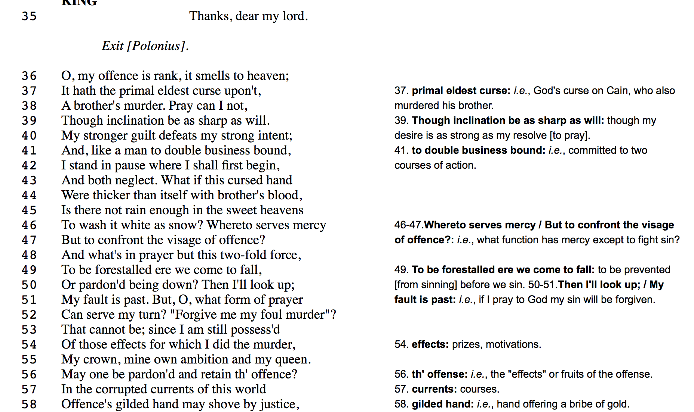
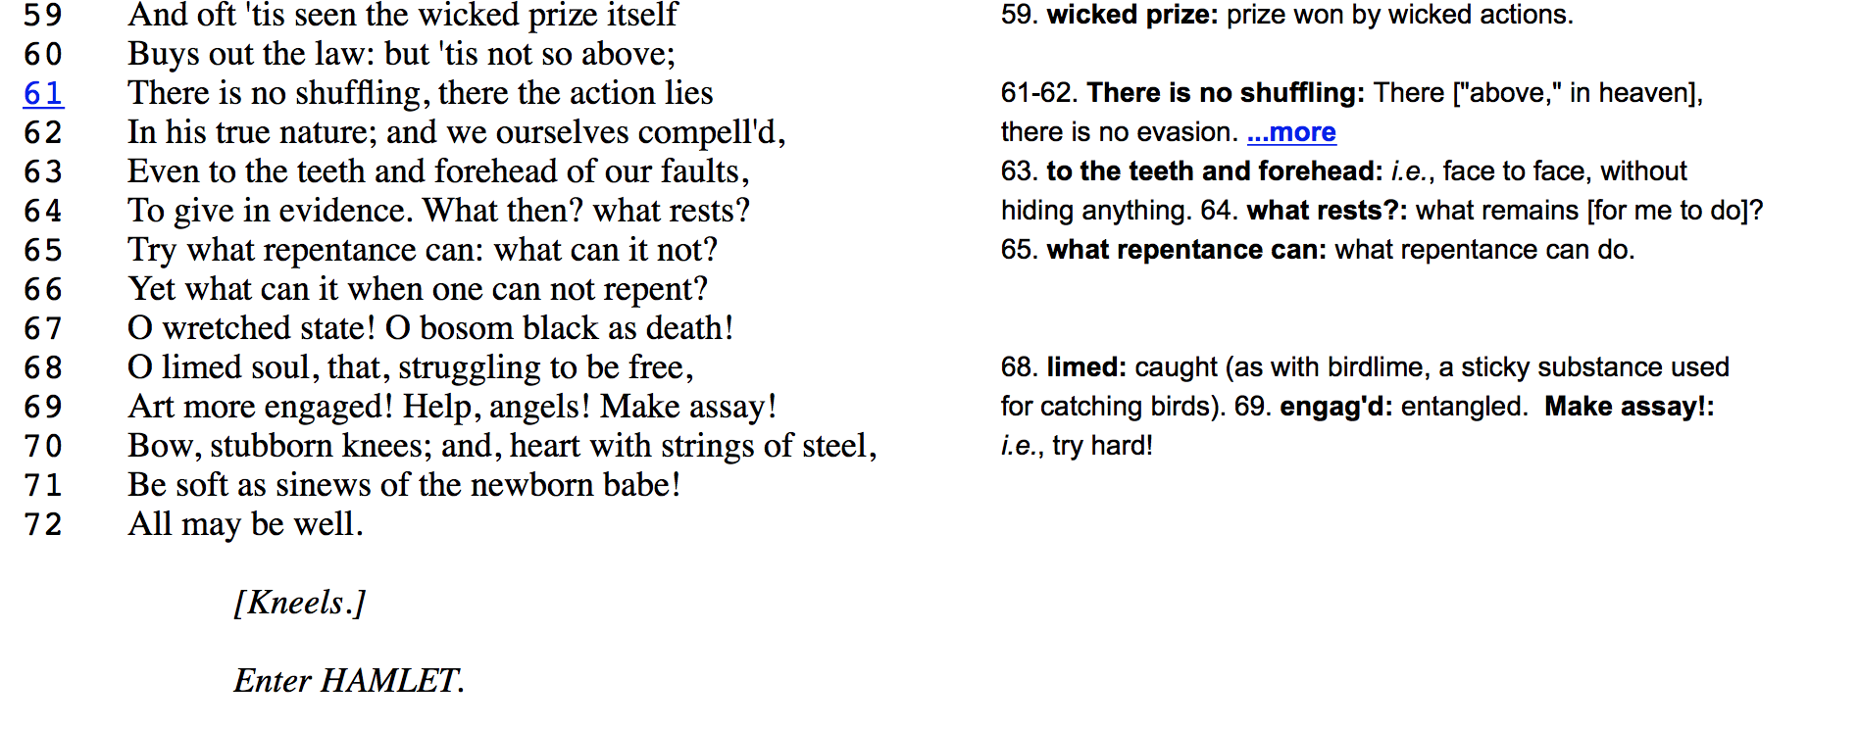

TASKS:
In the speech above, highlight and label three style devices.

Summarize what he is saying below:

In line 55, he says “my crown, my ambition, my queen”. Are the three mutually exclusive? Why or why not?
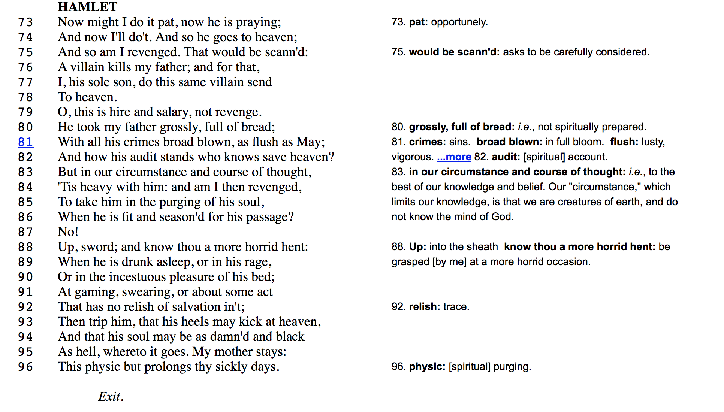

TASKS:

Summarize what is Hamlet is saying below:

Why doesn’t Hamlet murder Cluadius right then and there?

Do you think he has the guts to kill Claudius? Why or why not? Is this reasoning just an excuse?

What is Claudius’ final point of view about his own guilt?

Deception in Hamlet
Deception is an essential element of Shakespearean drama, whether it be tragedy, history, or comedy. The deception can be destructive or benign; it can be practiced on others or, just as likely, self-inflicted. On occasion deception becomes the very foundation of a play, as is the case with Twelfth Night, Othello, and, most notably, Hamlet.

1) Hamlet's feigned madness is an act of deception. Read Hamlet’s directions to Horatio below (page 67 in our books). How does he plan do deceive the King? Why does he do this? What does this passage mean?

Here, as before, never, so help you mercy,
How strange or odd soe'er I bear myself,
As I, perchance, hereafter shall think meet
To put an antic disposition on,
That you, at such times seeing me, never shall,
With arms encumber'd thus, or this head-shake,
Or by pronouncing of some doubtful phrase,
As 'Well, well, we know'; or 'We could, an if we would';
Or 'If we list to speak'; or 'There be, an if they might';
Or such ambiguous giving out, to note
That you know aught of me: this is not to do,
So grace and mercy at your most need help you.
(187-199)

2) Hamlet stages The Murder of Gonzago, itself an elaborate deception with what purpose in mind?

Below are the directions he gives to Horatio. Why does he do this? What do the words mean?

Give him a heedful note
For I mine eyes will rivet to his face,
And after we will both our judgments join
In censure of his seeming.

3) Hamlet schemes to deceive his mother, Gertrude, at their meeting in her closet. How does he “plan” to appear to his mother? Why doesn’t he have plans to be physically brutal? What purpose does this serve?
Soft now to my mother. O heart, lose not they nature, let not ever The soul of Nero enter this firm bosom: Let me be cruel, not unnatural: I will speak daggers to her, but use none; My tongue and soul in this be hypocrites; How in my words soever she be shent, To give them seals never, my soul, consent! (3.2.)

4) When Hamlet discovers Rosencrantz and Guildenstern carrying his death warrant on the ship bound for England he changes his name to the names of his unwitting companions, thereby sending them to be executed in his place. This unusually ruthless act of deception shocks and disappoints Horatio. Why?

Hamlet. I had my father's signet in my purse, Which was the model of that Danish seal: Folded the writ up in the form of the other, Subscrib’d it, gave’t the impression, plac’d it safely, The changeling never known. Now, the next day Was our sea-flight; and what to this was sequent Thou know’st already.
Horatio. So Guildenstern and Rosencrantz go to't... Why, what a king is this? (5.2)

5) Hamlet's philosophical reluctance to murder Claudius results in self-deception several times in the play, particularly in his soliloquies. He convinces himself to delay in his second soliloquy because the Ghost might be playing false: "The spirit I have seen/May be a devil, and the devil hath power to assume a pleasing shape" (2.2). What clues have been given by Shakespeare through indirect characterization that this statement is a falsehood?

UNDERSTANDING IT ALL: ACT III.2-ACT IV.2
(ANSWER ON A SEPARATE SHEET OF PAPER)
- What does Claudius fear will happen to his people and to himself if Hamlet remains in Denmark?
- What does he mean when he says “For we will fetters put about this fear, which now goes too free-footed”? (163)
- How is Polonius punished for his nosiness? What is symbolic about the curtain shielding Hamlet from what he is doing?
- How is Polonius wrong about how Gertrude reacts to Hamlet? How does this further confirm Hamlet’s statement that “Frailty! Thy name is woman!”?
- Is in his guilty acknowledgment on page 165, Claudius sounds much like Lady Macbeth hyperbolizing her guilt (remember “All the perfumes of Arabia will not sweeten this little hand”). Quote the similar lines from Claudius’ speech.
- Why doesn’t Hamlet kill Claudius when he is praying?
- When Hamlet kills Polonius, he is stark raving mad. Is this real or just part of his “antic disposition”? Why or why not?
- How does Gertrude show delayed guilt? Is this feigned or real?
- Why can’t Gertrude see the Ghost? Why did the ghost appear?
- What does Hamlet hope happens once he dispatches to England?
ACT IV: i
- At this point, does Gertrude feel any guilt? How does she describe Hamlet to Claudius?
- How does Claudius react to hearing about Polonius’ death?
- What is Claudius most worried about?
ACT IV:ii and iii
- Why doesn’t Hamlet want Polonius to have a good Christian burial?
- What does the riddle about the body mean?
- In his opening speech, Claudius says that the offender’s “scourge is weighed, but never the offence” (people play attention more to the severity of the punishment and not the crime). Do you think this is true nowadays? Why or why not?
- What joke does Hamlet make about the desecration of Polonius’ body?
- Why big lie does Claudius tell Hamlet about his upcoming trip?
- How does Hamlet emasculate his stepfather?

V. i. OPHELIA’S FUNERAL

1) Why do the gravediggers question Ophelia’s burial?
2) As the grave is prepared, what physical things are on stage that remind you of death?
3) What has the graveigger heard about Hamlet?
4) Who is Yorick? What does Hamlet do with his skull?
5) When Hamlet sees the funeral procession, what is he not aware of?
6) Consider the clowns’ comments and Hamlet’s observations about the procession in comparision with Gertrude’s description of Ophelia’s death. What conclusion can you draw?
7) Why does Laertes jump in Ophelia’s grave? How does Hamlet react?
8) For the first time, we hear Hamlet speak in utter sincerity to Ophelia. What does he say?

THE POISONED KINGDOM
From the pre-play action of Claudius pouring poison in to the late king’s ear to the tainted sword and cup at the end of the play, poison is one of the major motifs in Hamlet. There are literal poisons that kill Hamlet, Gertrude, Hamlet Sr., and Laertes for example and metaphorical poisons that reflect the rotteness of Denmark.
1.) Who is the source of poison in this play?
2.) How does the initial poisoning become prime cause of an escalation of future poisonings, both literal and metaphorical?
3) In what sense are Laertes, Ophelia, Hamlet, R&G, and Gertrude poisoned long before they die?
4) How did the poisoning scene in the pre-play and actual play showcase this motif?
5) Is Denmark purged of poison in the play’s conclusion? Explain.

