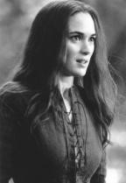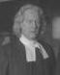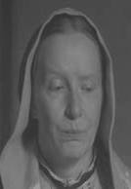THE CRUCIBLE CHARACTER ANALYSIS

CHARACTER | DESCRIPTION OF CHARACTER | MOTIVATION FOR ACTIONS | PERSONALITY TRAITS
Abigail Williams
Betty Parris
Reverend Parris
Ann Putnam
Mary Warren

CHARACTER | DESCRIPTION OF CHARACTER | MOTIVATION FOR ACTIONS | PERSONALITY TRAITS
Thomas Putnam
Tituba
John Proctor
Elizabeth Proctor
Giles Corey
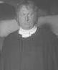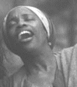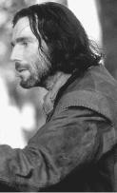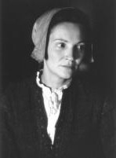

CHARACTER | DESCRIPTION OF CHARACTER | MOTIVATION FOR ACTIONS | PERSONALITY TRAITS
Reverend Hale
Danforth
Rebecca Nurse
Mercy Lewis
Marshal Herrick
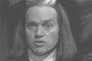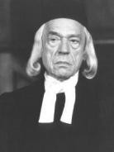

USE EACH CHARACTER’S NAME ONLY ONCE TO COMPLETE THE FOLLOWING:
List the characters from the chart who were in the woods:

Divide the characters from the chart into the following two groups. Place a star by any character who later switches to the other belie

THOSE WHO BELIEVE WITCHCRAFT IS TO BLAME

THOSE WHO BELIEVE THE GIRLS ARE LYING

List the characters from the chart who are dead by then end of the play:

